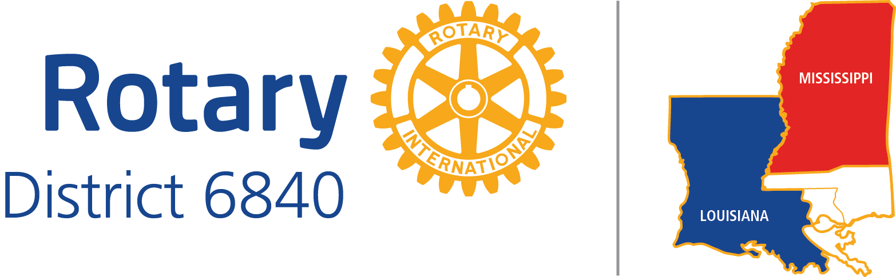

CLUB LEADERSHIP OBJECTIVES

Date: December 13, 2016

POSITION TITLE: CLUB CHAIR FOR VOCATIONAL SERVICE

DISTRICT EXPECTATIONS:

1. Teach your club what Vocational Service is.
2. Plan and implement Vocational Service Projects.
3. Respond promptly to District communications.
4. Carry out any tasks mentioned for your position in the District Long-range Plan.

5. Attend District Meetings

Before your year begins:

1. District Training Assembly if training for Club Vocational Service Chairs will be offered. Ask.

Before your year and during your year:

2. District Conference. At the conference you will be able to learn and discuss Vocational programs for your club.

BEST PRACTICES:

1. Have a “Rotarian Speaks” at each of your meetings (or one per month). Give a Rotarian 5 minutes to simply talk about themselves and their businesses. Have them discuss what they do, how it helps the community, and most importantly how they practice ethics in their business.

2. Ask for volunteers to host an “After Hours” at their office to discuss their business and have people tour their office. This is also a great event to invite prospective members to as well. Some clubs do a “Road Show” and have their regular meeting at a business in the community.

3. Have Rotarians in your Club attend an Interact Club meetings and have the Rotarians discuss their vocations. This doesn’t have to take place at an Interact Club that your Club sponsors. It doesn’t have to be an Interact Club at all.

4. Invite students to attend a day of job shadowing at your office.

5. Recognize a local business leader in your community. Have a designated event or simply recognize them at a meeting. Or honor a major business sector in your community with awards rarely given, e.g. tourism industry awards for concierge, sous chef, taxi/Uber driver, police, fire, tourist attraction docent, etc.

